**City University of Hong Kong**

CS3343 Software Engineering Practice

Project Plan

Project Title: Club Management System

**Group**: 2 **Tutorial** **Session**: L01

|  |  |
| --- | --- |
| **Name** | **Student Number** |
| WANG KA CHUN KEVIN | 55229123 |
| WONG SIU FAI | 55223247 |
| HO KWAN TO | 55233726 |

Project Description

Our company, Nexus, mainly design management systems for large companies, for example, Library Management System, Staff/Employees Management System. Nowadays, manage hundreds of teachers is not easy, especially with them manage different extra curriculum activities (Clubs). Using an intelligent system can lower the cost, reduce human errors, and also increase efficiency. Therefore, we develop a club management system, NextGeneration.  
  
NextGeneration accepts, stores, and updates the information of teachers and clubs. The ultimate goal is to provide an efficient way to access and manage all the teachers' records.

Stakeholders

|  |  |
| --- | --- |
| **Stakeholders** | **Responsibility** |
| Teacher | 1. Provide information 2. To request leaves by inputting to the system 3. To be in charge of classes |
| Manager (Human Resources) | 1. Manage teachers’ and clubs’ records |
| Admin | 1. Administrative rights of the system |
| Project Team | 1. Develop the system 2. Design a simplified UI for more comfortable access |

Objectives of the Project

NextGeneration aims to help teachers have an overview of all his students in one place. With one click, the system will show all the records of the clubs and leave records. It can reduce lots of human resources and time to tracing the records.

Risks and Resource Constraint

Due to limited human resources and time, we have our system in the form of light code, and simplicity is the central aspect of our whole development process.

Also, we will have a weekly backup system to protect the data. Backups are useful for restore when data corruption occurs.

Main Functions

1. **Hiring**When the school had hired a new teacher, his/her name will be entered into the system together with days of annual leave.
2. **Extra Curriculum Class (Clubs)**  
   Each teacher can manager one or more clubs, even no clubs. The team head will also assign along with the team formation.
3. **Take Leave**Teachers are allowed to take leaves based on their requests, like No-pay Leave, Annual Leave, Compensation Leave.
4. **Display**The system can list out all the clubs, club members, and teachers who are on leave with the reason.

Software Development Methodology: Waterfall development method

0.0 Student Management System  
1.0 Project Management  
2.0 Requirements Gathering  
 2.1 Topic Discussion  
 2.2 Research  
3.0 Design & Analysis  
 3.1 Algorithm Design  
 3.2 Database Design  
4.0 Software Development  
 4.1 Algorithm Implementation  
 4.2 Database Implementation  
5.0 Testing & Development  
 5.1 Unit Test  
 5.2 System Test  
 5.3 Integration Test  
 5.4 User Acceptance Test

Development Tools

|  |  |
| --- | --- |
| **Development Tools** | **Purpose** |
| Eclipse IDE | Develop JAVA Software |
| Junit 5 | Test Case Automation |
| Google Drive | File Sharing |
| GitHub | Collaboration/Version Control |
| TeamGantt | Project Scheduling |
| Visual Paradigm | Diagrams Drawing |

Project Schedule

The project cost 13 weeks to finish. There will be no allowance on the deadline, which the system must finish at the beginning of December. Therefore, we design a Gantt chart for the teammates to stick on schedule and finish each stage on time.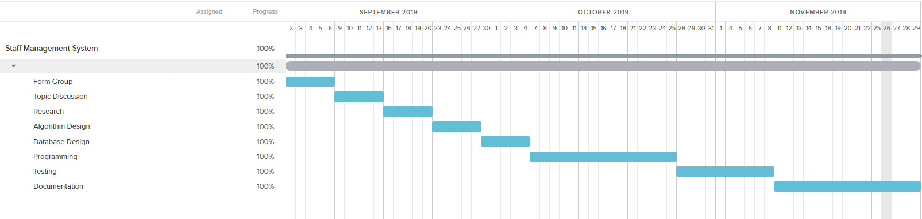

Future Planning

After we released the official public version of NextGeneration, we will keep developing to enhance the user experience of the system.

1. **Manager Approval System**The current version does not require the manager to approve the teachers’ leave requests. Our team will implement an approval system to let the manager prove the request. Otherwise, the staff cannot take his leave.
2. **Graphical User Interface**The current version does not provide a GUI for the user to input or search for any information. In the future, we will develop GUI and forms to enhance user experience and reduce human errors.